

**BOSTON | SEATTLE**

**187 Ballardvale St. Suite A195 ●Wilmington, MA 01887● Ph: +1.978.694.1008**

[**getsecure@securityinnovation.com**](mailto:getsecure@securityinnovation.com)**●** [**www.securityinnovation.com**](http://www.securityinnovation.com)

|  |  |
| --- | --- |
| **Document name:** | Decompiling Android Applications |
| **Author(s):** | Dinesh Shetty |



Decompiling Android Applications

# Contact Information

### Technical Contact

Dinesh Shetty

Senior Security Engineer

Email: [dinezh.shetty@gmail.com](mailto:dinezh.shetty@gmail.com)

# Test Configuration

The following is required to verify this issue:

* Download the latest version of the Android-InsecureBankv2 apk from <https://github.com/dineshshetty/Android-InsecureBankv2>
* Download the latest version of JADX decompiler from <https://github.com/skylot/jadx>
* Download latest version of dex2jar from <https://bitbucket.org/pxb1988/dex2jar/downloads>

# Test Steps

1. Unzip the contents of the originally downloaded InsecureBankv2.apk file using the below command:

unzip InsecureBankv2.apk

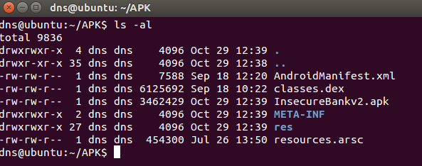

1. Copy the classes.dex file to the dex2jar folder. Make the d2j-dex2jar.sh and d2j_invoke.sh files executable by running the below commands.

chmod +x d2j-dex2jar.sh

chmod +x d2j_invoke.sh

1. Use the below command to convert the dex file into a jar file:

sh d2j-dex2jar.sh classes.dex

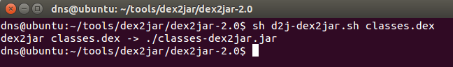

1. Open the generated classes-dex2jar.jar file in JADX-GUI decompiler using the below command:

./jadx-gui <path to classes-dex2jar.jar>

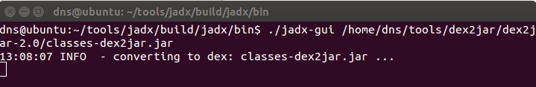

1. The following screenshot shows the decompiled code for the Android-InsecureBankv2 application.

